Title: | Minimum Standards: Evaluation report
Date: | January 2024
Author: | Sarah Halsall, Placements North West
Report to: | Commissioning Managers

Summary
This is an evaluation of the North West Minimum Standards which were introduced to supplement local authority monitoring visits and quality assurance for Supported and Independent Living (SaILS) providers as this was unregulated until October 2023.

With the introduction of regulation for Supported Accommodation providers from 28 October 2023 the Minimum Standards work will come to a natural end and learning applied to ongoing regional monitoring approaches.

The Minimum Standards were co-produced with providers and have been subject to iterative review and refinement since their launch in 2010. Most recently this has included amendments to facilitate remote assessments due to the restrictions resulting from the Covid-19 pandemic and consideration of how to support providers as supported accommodation becomes regulated.

Highlights
- 109 providers have had one or more Minimum Standards assessments completed since 2016.
- 44 of the providers on the 2020 contract had a Minimum Standards Assessment between 2016-2020 whilst part of the PIMS contract. (57 providers on PIMS, 37 off contract)
- Providers and local authority stakeholders provided positive feedback on the impact of the Minimum Standards on the quality of supported accommodation in the North West.

Timeline
2009: Regional consultation between small group of leaving care providers and representatives from local authority leaving care and commissioning teams led by Placements North West. Set of standards developed based on current guidance for Children’s Homes.
2010: Minimum Standards launched with the aim of ensuring safe and appropriate accommodation for those 16 and 17 year olds leaving care or becoming homeless. There are eight standards with additional criteria to be met within these. Providers had to be registered on the PIMS (Placement Information Management System) to be assessed on the standards. Where criteria were not met an action plan was put in place. The process was entirely voluntary though over time individual authorities started to insist providers undergo the Minimum Standards before placing any young people with them.
2011: Review of the Minimum Standards results in their being streamlined into six sections.
2012: Changes to reflect Building Regulations introduced to the standards.
2013 – 2014: Process developed to include pre-assessment visit checks on Safer Recruitment and Safeguarding policies. Criteria introduced around physical intervention and medication to clarify the line between care and support. Re-assessment visits were introduced to be undertaken a year after the first visit to check Standards (and any action plan requirements) had been embedded into practice.
2016: Minimum Standards updated to reflect tender criteria for the regional DPS. New elements around support provided, involvement of young people, location risk assessments and preparation for adulthood included.
2018: Review of regional commissioning arrangements and new Supported and Independent Living Services (SaILS) DPS goes live.
2019: Additional standard to introduce staffing introduced.
2020: Covid-19 pandemic required move to carry out wholly virtual Minimum Standards assessments. Department for Education launch consultation on new national standards for supported accommodation.
2022: Consultation on new contractual arrangements for a post regulation context starts.
2023: Introduction of new Supported Accommodation (Young People) FPS with contract requirements reflecting new regulatory regime.

Principles

The Minimum Standards assessments are not regular monitoring visits and are not intended to replace local authority monitoring but to get a basic level of quality and consistency across the region. The visits do not cover the quality of support provided, young people’s records or outcomes as this would be the role of the placing authority.

The latest iteration of the Minimum Standards assessment includes:
- Safer Recruitment
This standard is in place to ensure providers are recruiting safe staff for our young people in this unregulated setting.
Criteria ensures all staff working with young people are subject to the relevant checks and hold the relevant qualifications to carry out their role safely. Includes checks that Providers are monitoring staff via supervisions and training, including sharing of good practise amongst staff.​
This standard includes a subcategory requiring providers to include Young People in the recruitment process, giving them a voice.​

- Safeguarding
Providers must have a robust policy explaining the different types of abuse, how to spot them and ensure there are processes in place to raise concerns and record incidents. Additionally, we ask for a robust Child Exploitation policy that not only details CSE risk but includes Gang affiliation, Trafficking and slavery, Radicalisation, and extremism. Including policies in place for whistleblowing, Anti-bullying for staff and young people, lone working.​
Training and processes are key, and this standard sets out what is expected of providers and staff.​

- Health, safety and fire risk
This standard details the processes in place for the properties used by young people. It sets out the minimum checks needed including fire risk assessments and H&S risk assessments as well as regular checks on the YP accommodation. It must include emergency evacuation procedures, fire equipment and contact details for young people should they encounter any issues.
This standard includes policies on non-physical intervention, administration of medicines and CCTV.

- Buildings regulations /requirements
This standard includes checks on potential planning permission and licences needed. It requires providers to prove they have done relevant H&S and property checks and that the properties are upto a certain standard for Young People to occupy. It includes checks such as PAT testing, Gas safety.

- Delivered Support
Providers must have a clear process for recording and monitoring the support provided to young people. ​Providers must demonstrate what they have in place for each young people such as; pathway plans, feedback and a formal working towards independence program should be identified. ​Providers should have mechanisms in place to assist young people once they turn 18. ​
This is one of the key standards in ensuring positives outcomes for young people are achieved.
- Quality assurance and monitoring including complaints process
This standard includes processes for individual risk assessments, Behaviour agreements, CSE screening/ risk assessments, ​Missing from home procedures and complaints procedures.
The standard includes checks on the property to ensure young people have everything they need.
- Staffing and visitor Records
This standard is in place to ensure there are processes for staff rotas, number of staff on shift and out of hours arrangements.

Methodology
Step 1: Desktop review
Providers submit around 35 documents as part of the tender process, which contribute to the Minimum Standards assessment. The Monitoring Officer completes the initial report by checking the policy includes the criteria. Any missing criteria is identified as a Provider action. Once the initial desk top review is complete, the report is sent to the provider to read and complete the actions. (10 working day deadline)

Step 2: Provider to complete the actions and forward any outstanding or amended documents to support their response.

Step 3: Monitoring officer to review the answers and amended documents (anything still outstanding should be discussed with the provider and put into an action plan with another 10 day deadline)

Step 3b: If an action plan is in place the provider must meet the criteria within the extra 10 working days given. If this is not completed an Information sharing protocol (ISP) would be issued and the provider has 3 months to clear up any outstanding issues.

Step 3c: If the provider does not complete the report to satisfaction in the 3 months, they would be removed from the contract.

Step 4: An in-person visit is arranged to complete staff checks and view a property if possible. During Covid-19 this was changed to a Teams video call and the provider submitted a video walk through of the property.

Step 5: Once the provider has met all the standards, the report would be finalised and shared with Local Authority colleagues.

Providers who only offer Floating Support received a shortened version of the assessment to acknowledge that they do not need to meet the standards around accommodation.

Outcomes
- 106 providers have had one or more Minimum Standards report completed since 2015.

Year | All Standards Met | All Standards Met following an Action Plan | Action Plan not completed | ISP issued
2016 | 11 | 13 | 3 | 1
2017 | 22 | 7 | 1 | 5
2018 | 20 | 7 | 0 | 3
2019 | 7 | 1 | 0 | 0
2020 | 18 | 1 | 0 | 0
2021 | 24 | 1 | 0 | 0
2022 | 4 | 1 | 0 | 0
2023 | 12 | 1 | 0 | 0
Total | 119 | 32 | 4 | 9

- The table shows that in 2016 almost 50% of the providers did not pass the standards first time and had to go through an action plan to meet the criteria.
- 2022 only 5 were completed due to staffing changes in the team. This slowed the progress of completing the assessments.

The reduction in ISPs and actions plans is likely due to pre-tender training, guidance shared with providers to prepare them for tender and the expectations of the standards, publishing the Minimum Standards on our website so providers could prepare more easily and a more relational approach to supporting providers to meet the criteria. Additionally, as some providers had more than one assessment, they were more prepared and had policies in place at the second assessment.

Impact
15 providers and 12 local authorities provided feedback on their experience of the Minimum Standards; all was overwhelmingly positive about the impact of this work on the quality of supported accommodation provision in the North West. A full set of responses can be found at Appendix A: Stakeholder feedback.

“Having worked with the PNW standards for many years and with different organisations, I saw the impact grow year by year. As time progressed, it became more difficult for organisations who were not on framework to place young people as the Local Authorities were less inclined to use off-framework providers. This persistence from the Local Authorities forced a lot of providers to apply to PNW which meant they had to enhance their services and improve quality, which I believe was needed. I personally am grateful to PNW and the minimum standards as it has helped to set the standard we should all be working to and provides a clear guide for providers to base their practices. I do feel that over the years PNW have had a positive impact on this sector.” Provider

“It provided a good baseline of quality and held providers to account when there was no Regulation." Local authority

Key points from the feedback included:
- In the absence of regulation, they set out a standard for providers to meet;
- Minimum Standards set out a clear expectations on the quality of provision expected by North West authorities and the prioritisation of providers who had met the standards pushed providers to meet them;
- Providers used the Minimum Standards to carry out internal assessments;
- It was helpful for providers to have been working to the Minimum Standards when it came to the introduction of regulation and North West providers were better prepared than those in other areas;
- Minimum Standards reports provided a basic level of monitoring to support local authority due diligence;
- The reports were thorough and detailed but were not able to be updated regularly enough due to capacity and the number of providers.

Learning
As the Minimum Standards has come to a natural ending, we still need to ensure ongoing monitoring is completed to give reassurance to Local authority colleagues. Additionally, we want to ensure it is a simple process for providers and doesn’t duplicate other monitoring or inspections.

Both Providers and Local Authority colleagues who completed the feedback forms agreed that the Minimum Standards have helped improve the quality for supported accommodation but that the system of quality checking providers should change with the introduction of Ofsted monitoring.

We agree that the minimum standards cannot continue as they are as Ofsted will check their policies and procedures during the registration process and inspections, and it would be unnecessary duplication. However, we do want to continue checking some aspects of the standards (that we feel Ofsted don’t cover in the same detail) and feel that we could introduce these into our ongoing quality monitoring tools for LA’s and annual checks to ensure standards continue to be met between inspections. This also addresses the feedback from Local authority colleagues that the reports weren’t regular enough. With the combination of LA due diligence, ongoing QA and our annual checks we envisage more consistent monitoring.

From the feedback from both providers and LA, it appears that in person visits are highly valued. We intend to include spot check visits as part of the annual assessments, however, it would not be possible to visit all Providers due to team capacity. It is essential (but understandably not always possible) for LA’s to visit the properties before placing a child to get a genuine impression of the property and the condition, it is crucial to remember the minimum standards are just that, what we expect to see as a minimum and a snapshot in time.

Going back to the early years it was clear that some Providers didn’t have the right policies and procedures in place due to the lack of regulation or guidance on this type of provision. The Northwest’s collaboration with stakeholders to create the standards brought that basic structure into play and helped providers raise the quality of provision. The introduction of the Regulations has not been as much of a shock to the Providers we have worked with as they are already meeting most of these criteria due to the Minimum Standards.

Next steps
Learning from the Minimum Standards will influence ongoing workstreams within the North West including:

Annual Checks
Introduction of a self-assessment annual check document.
This would cover various aspects such as: safer recruitment checks, staff structure, building and safety checks, Insurance, placement information.
This form can be completed on the NWADCS website and accessible to LA colleagues. Any queries picked up on this may lead to a spot check for a more in-depth assessment.

Spot check
Spots checks will be used to check a Provider’s annual self-declaration is correct. These will be selected randomly on a small selection of providers each year. Spot checks will also be carried out when any issues or queries raised in due diligence or QA checks are raised.

Regional Quality Assurance template
Introduction of a regional QA template for Supported Accommodation providers that PNW and LA colleagues can use to assess the provider prior to inspection as well as ongoing monitoring.

The most common pitfalls were Safer Recruitment and Health and Safety.
Those who required actions plans (2020 contract) either failed initially on these two criteria or all criteria.
The most common issues for Safer Recruitment were:
- checking of gaps in employment
- recording employment and education dates in months and years
- DBS checks not being done prior to employment start date
The most common issues for Health and Safety were:
- the policy wasn’t fully reflective of practice.
- the policy didn’t reflect regular and annual checks
- the policy was too large/not suitable for the provision

These areas will be the focus of the ongoing monitoring in the new Supported accommodation contact. The QA template includes a number of tabs/subjects. The intention would be to assess all providers unknown to us (not on a previous contract) on the Safer Recruitment tab and the H&S tab first, whilst other Providers will only need to complete the annual self-assessment. Going forward a variation of full QA, part QA and the Annual Checklist will be used to monitor Providers.

Further information
Additional data and information can be made available to North West authorities.
Please contact placementsnortwest@stockport.gov.uk for more information on this project.

Appendix A: Stakeholder feedback

- Responses from providers

Do you think that the Minimum Standards helped to improve quality for supported accommodation? 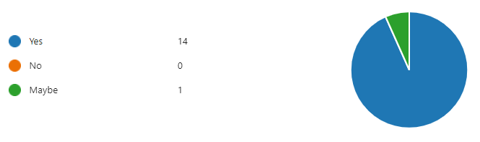
- It ensures that providers are working towards a high level of support for young people.
- I think they were very helpful when there was no Ofsted inspection regime.
- It is something to work against. It clearly showed the requirements for providers and what the outcomes were that we were working towards.
- This helped as it gave a better understanding.
- In a time of unregulated activity, they provided an element of accountability. It developed better outcomes and expectations in the Northwest than most other regions. I do not think they went far enough, and we as regularly checked as they could have been had team capacity been larger.
- Maybe - If visits are also conducted to assure providers are providing what they say they are.
- The minimum standards provide a framework to monitor your services against, to make sure you are achieving the best outcomes for young people.
- Prior to OFSTED they have been a very useful framework in the absence of other
- How could it not? It was better than no standards which was what was in place before that.
- It will improve accommodation and outcomes for young people.
- Having working with the PNW standards for many years and with different organisations, I saw the impact grow year by year. As time progressed, it became more difficult for organisations who were not on framework to place young people as the Local Authorities were less inclined to use off-framework providers. This persistence from the Local Authorities forced a lot of providers to apply to PNW which meant they had to enhance their services and improve quality, which I believe was needed. I personally am grateful to PNW and the minimum standards as it has helped to set the standard we should all be working to and provides a clear guide for providers to base their practices. I do feel that over the years PNW have had a positive impact on this sector.
- Minimum Standards give structure and a focus to Service Providers as these standards are also used to internally quality assess the work we do, our outcomes, and assess if we are meeting our objectives and KPIs. They support quality improvement planning and assess if we are fulfilling our contractual obligations. But more importantly ensures the service user who is at the centre of this are also aware of what they can expect and that they are achieving positive outcomes.
- It provides clear understanding of expectations for Supported Accommodation.

Do you think the Minimum Standards helped North West providers be better prepared for regulation?
- Regulations were very similar to the national minimum standards.
- Providers should have been working to good standards regardless of whether we were registered with Ofsted. I think the standards might have helped those organisations who may have been working below the standards.
- It is an extremely time consuming and costly process which we are still working through. It can be more difficult to change systems and structures that are in place than it would of been to start from scratch.
- This help put us in a very good position for when the regulations was issued.
- The starting point of many Northwest providers has clearly been more ahead than in many other regions, regional benchmarking supported that.
- Gave us a foundation to work from
- The standards helped put the company into a regulatory mindset to ensure we deliver a high quality service meeting individual need.
- Baseline procedures/policies and safety requirements have been in place due to the minimum requirements.
- I think it provided providers to be ready for registration and meeting the regulations.
- For providers working to PNW standards, most aspects of the regulations were already covered, and just required some tweaks. Some changes were needed to meet the new regulations, but it was made easier by already working to quality standards. PNW were also a good source of information and support leading up to regulation.
- Ofsted coming along is not so daunting knowing that we have been following the standards anyway. Minimum standards and regulation are inextricably linked.
- The document gives all the required standards to ensure quality provisions are obtained/maintained.
- Although not very in depth they gave us an idea of things we’d need to be aware of.

Please rate your overall experience of taking part in the Minimum Standards
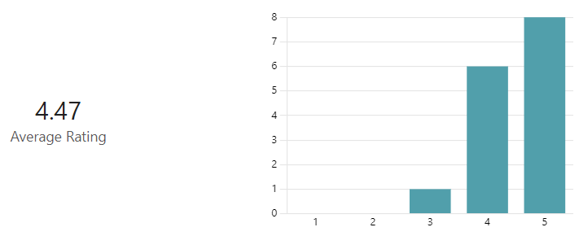

- Responses from local authorities

Do you think that the Minimum Standards helped to improve quality for supported accommodation?
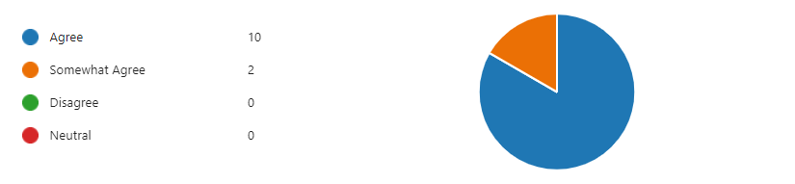
- It provided a good baseline of quality and held providers to account when there was no regulation.
- They are minimum and as such give a minimum level of reassurance.
- Without it, Providers had no idea about minimum expectations.
- Any reviews that check standards are being followed and upheld will encourage providers to maintain the quality local authorities require.
- I feel it give framework and structure and guidance to providers, I also feel it put a level safety and precautions for the industry ensuring skilled staff and business have the level of understanding. I feel it gives framework that this is also an important care setting and not a quick win for profit
- This has indicated to us that providers have the necessary systems in place however, it has been difficult for PNW to keep updated reports on all providers.
- Give thorough understanding on what providers are offering and what standards they are already meeting
- It allows us to know that the provider as everything in place that is required to accommodate our young people safely
- its gives us a good guidance in more detail rather than as a whole
- Its been embedded over a long period and providers know they cant just set up. Poor practice has been challenged.
- Prior to OFSTED regulation, the standards helped to raise the quality at settings. Providers seemed to take them seriously and spent a lot of time preparing.
- It is another level of oversight; we don't visit 16+ provisions enough so being able to see a report is reassuring.

How did the Minimum Standards support local quality assurance?

- The sharing of the reports across the NW.
- Not at all in all honesty - just as a marker
- We use the reports as part of our due diligence reassured that providers who met the standards had the basics in place
- Our quality assurance is twinned with the finding of the Minimum Standards. We will check the feedback from these and have a focus on areas that may have required further improvement.
- It showed us which providers had the necessary systems in place, and prepared providers for Ofsted registration.
- We are only considering using them going forward. But they are similar to the questions we would ask so we are integrating them into the quality assurance process.
- Minimum standards give all providers a base line that they need to meet and improve on. It allows LA's to complete more in depth QA's as they know what is already being provided
- It gives a good indicator of quality provision.
- We use the minimum standard docs as part of due diligence if we don't regularly work with a provider.
- They were very detailed and the PNW officer carrying out the visits was thorough and professional.
- We refer to the Minimum Standards Reports as part of due diligence and to make informed decisions.

Do you feel ongoing monitoring should still continue despite Ofsted now regulating the sector?
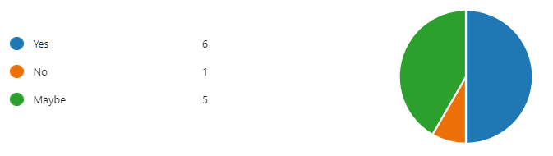
- We do not want to bombard or overload SA providers on top of regulation but the timeframes between Ofsted visits can be lengthy. A desktop review could be beneficial rather than a physical inspection visit.
- It is even more important from a local sufficiency perspective as we have a limited small market and cannot afford for any of them to fail an inspection.
- I feel that there is a transitional period that needs to be covered.
- It would be good to have the Minimum Standards up until the first Ofsted inspection. It would provide that added assurance that the provider is meeting expected standards. At times it can be difficult to do a QA before a young person is placed in the home and having some review would help our assurances.
- I feel the OFSTED framework should allow commissioning team to follow there generalised QA framework as the regulatory body has oversite unless the Ofsted is poor Commissioners should feel confident to referring back to normalised practise.
- Ofsted will have checked procedures. It may be useful for PNW to step in to co-ordinate reviews on behalf of the region, if local authorities raise ISPs in the future.
- Like we monitor children's home it gives us information on our young people specifically, checks that in between Ofsted inspections standards are being met.
- Monitoring should continue as they are more frequent than Ofsted inspections
- There should be a transition
- I think maybe a lighter-touch visit could be good- covering more providers, but in less depth. Particularly new providers or those joining the NW contract for the first time.
- Ofsted will not be able to complete monitoring visits to all the providers in a timely manner.

