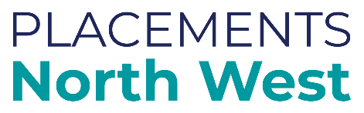

North West Template:

Out of Borough Consultation Checklist

**This template is designed to support verbal discussion with host authorities when placing a child out of borough.**

What Information about this child or young person needs to be made known to local services in the host authority:

* Safeguarding
* Health
* Education
* SEN and/or disability
* Youth justice
* Police
* Other services

What information do you need from the host authority before accepting the placement offer?

* View from social care on any existing placements with this provider?
* View from safeguarding on any concerns relating to provider or location?
* View from the LADO regarding any allegations, current or previous?
* View from commissioning regarding any provider concerns?
* Any other key information i.e. sign post to local offer.

NB the absence of local services to support may not be a reason to not accept the placement offer but identifies at the earliest opportunity, that other arrangements are required to ensure the child’s needs are met.

Based on this information:

* Do you feel the local area services are able to meet the needs of this child?
* Is there any other support or commissioning required to ensure the child’s needs can be met?
* Please ensure a record of this consultation is recorded appropriately.