North West Child Sexual Abuse Strategy
Outcomes Framework Guidance

This guidance has been developed to support the completion of the Child Sexual Abuse self-assessment “True to Us” exercise and action plan.

The NW Child Sexual Abuse outcomes framework details the following ambition:

- To improve the identification of child sexual abuse across the region
- To improve the response to child sexual abuse across the region
- To ensure that professionals have a better knowledge and increased confidence in identifying and responding to child sexual abuse.
- To improve information sharing/ seeking and multi-agency working across the region in relation to child sexual abuse
This document will detail the proposed outcomes, key performance indicators, potential data sources, and advise local areas on how this data could be accessed.
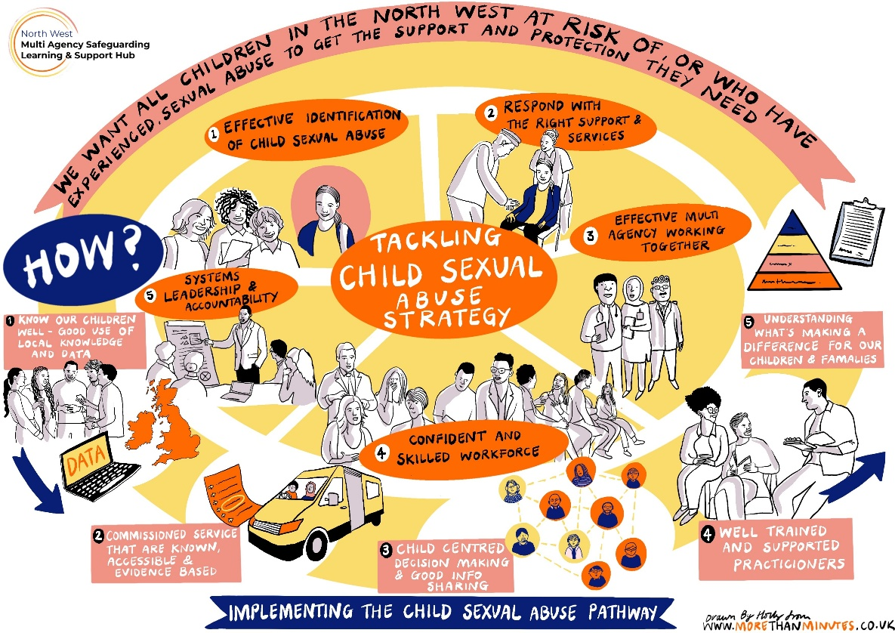

Outcome 1- There is improved identification of Child Sexual Abuse across the Region

Measure | Data Sources | Who Collects? | Indicators of success
Training data in relation to CSA across all agencies | Attendance data from training | All agencies/ NW RIPP | An increase in multi-agency attendance at CSA training including positive evaluation/ reflection.
Number of contacts/ referrals into the front door | Monitoring Data | Social Care | An increase in contacts to the front door from various agencies with CSA as a risk factor.
Number of contacts resulting in NFA. | Monitoring Data | Social Care | A reduction in contacts resulting in NFA at the front door.
Referral source | Monitoring Data | Social Care | Referrals being made from various agencies
Referrals to SARC | Case audits/ Monitoring Data | Health | Correlation with referrals citing CSA as a risk factor and referrals to SARC for support
Number of CAMHS referrals citing CSA as a risk factor. | Case audit/ Monitoring Data | Health | Correlation with referrals citing CSA as a risk factor to referrals to CAMHS for therapeutic intervention

Outcome 2- There is improved/ more effective response to Child Sexual Abuse across the Region

Number of strategy meetings relating to a concern of CSA | Case audit/ Monitoring Data | Cross Agency | Assurance that a strategy meeting has been held appropriately and all partners are in attendance. An increase in partner/ agency attendance at strategy meetings.
Number of S47 enquiries relating to CSA | Case audit/ Monitoring Data | Cross Agency | Assurance that a S47 enquiry has been undertaken with input from all partner agencies.
Number of Child Protection Plans under the category of CSA. | Case audit/ Monitoring Data | Social Care | Assurance in respect of the conversion rate from strategy meeting/ S47 investigation to ICPCC. A potential increase in the number of children being made subject to CP plans due to CSA because of improved awareness.
Timeliness of access to specialist support agencies. | Monitoring Data | Cross Agency | Assurance that children can access support in a timely way.
Outcome of CSC assessment in relation to the Police investigation. | Case file audit | Cross Agency | Less assessments resulting in NFA when a Police investigation does not progress/ continue.
Number of child sexual abuse offences per 1000 child population by type of offence. | Case file audit | Police | Increase in identified offences.
Number of charges brought in a police investigation related to CSA offences. | Monitoring Data | Police | Increase in charges brought.
Number of children penalised for harmful sexual behaviour. | Monitoring Data | Police | Reduction in children being penalised for HSB.

Outcome 3: Professionals have better knowledge and increased confidence to identify and respond to child sexual abuse
Professionals raising concerns in relation to CSA. | Practitioner surveys/ Audit Work | Cross Agency | Professionals feel more confident in reporting concerns of CSA
Professionals talking to children about CSA | Audit Work | Cross Agency | Professionals feel more confident in talking to children about CSA
Opportunities for practitioners, leaders and managers to reflect and share good practice. | Audit Work/ reflective sessions | Cross Agency | Opportunities to learn from what works within the system.

Outcome 4- There is improved/ more effective information sharing and multi-agency working across the region in relation to child sexual abuse.
Attendance at learning reviews/ Appropriate representation from all agencies. | Monitoring Data | Cross Agency | An increase in attendance at learning reviews.
How learning from reviews is shared with partners. | Practitioner Feedback | Cross Agency | Learning makes a difference to front line practice.
Focussed sub group specifically addressing CSA | Audit work | Cross Agency | Focussed dedicated multi agency sub group working on CSA.
Engagement with the Voluntary sector | Case file audit | Cross Agency | Increase in engagement.

