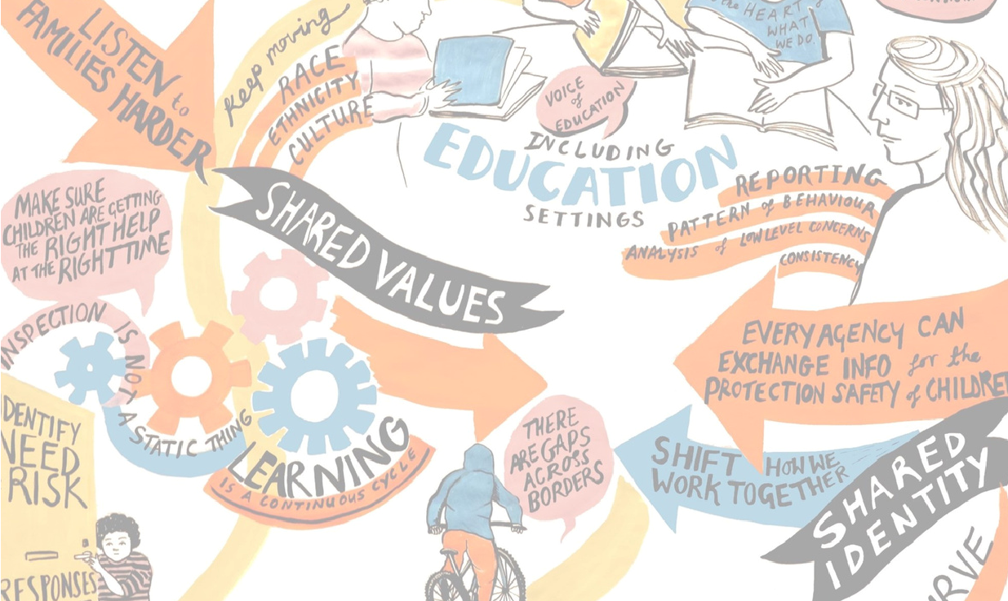
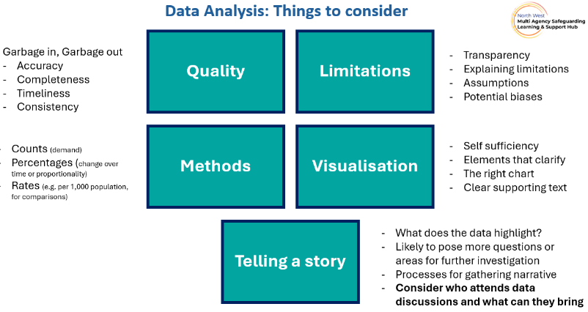
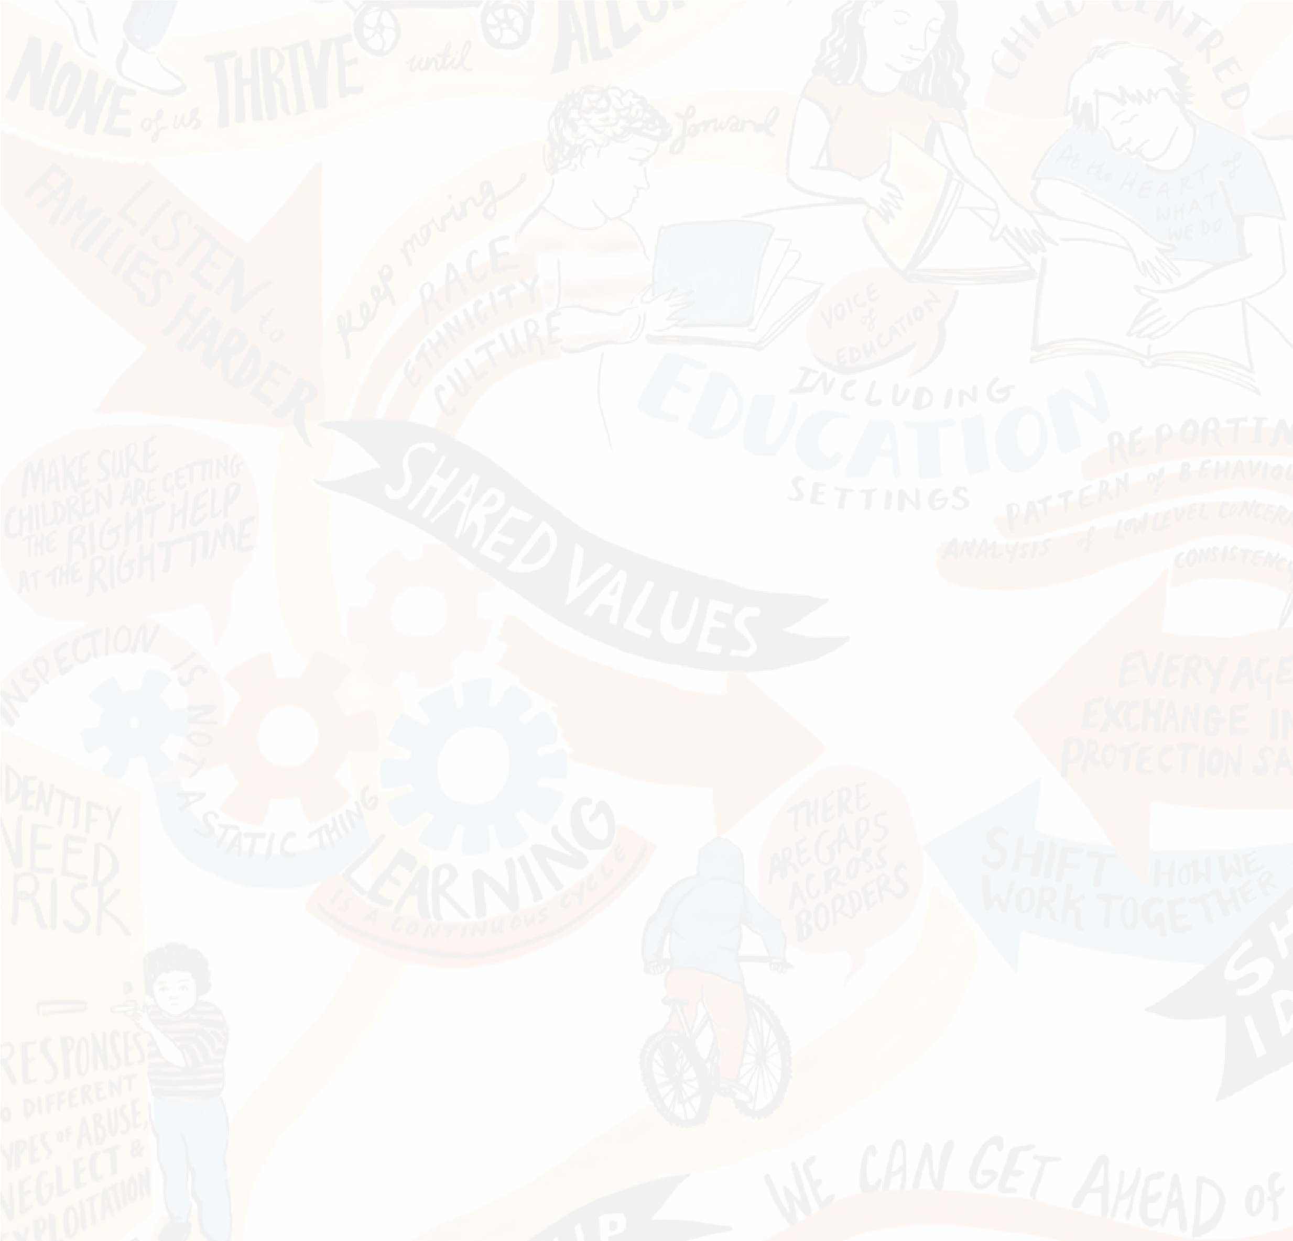
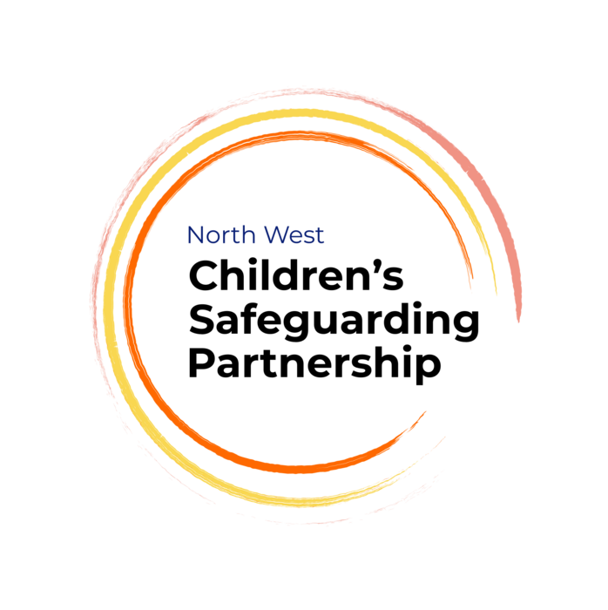
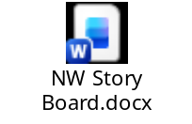
A MASA SAFEGUARDING EFFECTIVENESS FRAMEWORK should:
Consider Qualitative and Quantitative Evidence
Support a Partnership Culture - Where Good practice is Standard Practice
Support Accountability
Enable Challenge
Celebrate Success
NW Story Board / Narrative template
FOCUS ON PARTNERSHIP
Equal and shared ownership of what data is telling us from single agency narrative around help and protection for our children is vital.
What did we discuss and learn?

Interpreting Data Session

Enable, Share & Collaborate
Website: https://www.nwadcs.org.uk/north-west-childrens-safeguarding-partnership-mou
E-Mail: nwsafeguardingpartnership@stockport.gov.uk

HEARING FROM OUTSTANDING AREAS
Thanks to speakers from Durham on their ‘Think Tank’ model and Hartlepool and Stockton on Tees on their multi-agency dataset and Performance Framework development journey
ACTIONS
Don’t underestimate that small actions can have a big impact
Plan with Purpose!

NARRATIVE IS ESSENTIAL
Qualitative information, insights, and narrative are essential in data discussions.
KEEP IT SIMPLE
Partnership data can overwhelm - consider exception reporting, areas to focus and discuss ‘so what’ to dig deeper
INVITES
Who is/isn’t around your table to discuss data?
Non-stat partners can bring the most insights
CREATE YOUR CULTURE
Where everyone is valued and partners empower each other

