North West Multi-Agency Exploitation Dataset

Child Exploitation is currently a strategic priority area for 16 of the 24 multi-agency safeguarding partnerships in the North West. This dataset and guidance has been collaboratively developed in response to stakeholder feedback and identified needs. It is designed to support and enable North West MASA’s to embed and enhance the capture and discussion of multi-agency data and insights related to child exploitation.
Safeguarding partnerships are invited to utilise and adopt this dataset as they feel appropriate, to complement existing frameworks, rather than replace what is already working well.
This document details recommended data measures, potential sources, and guidance on why these measures have been deemed important and considerations for sub-group focused discussions. The guidance can be used to promote reflection in relation to exploitation practice, enable shared and consistent language and understanding and report baselines for comparison and benchmarking.
This dataset is aligned to the DfE Families First Partnership Guidance, embedding the principles of family help, partnership working and family led decision-making.
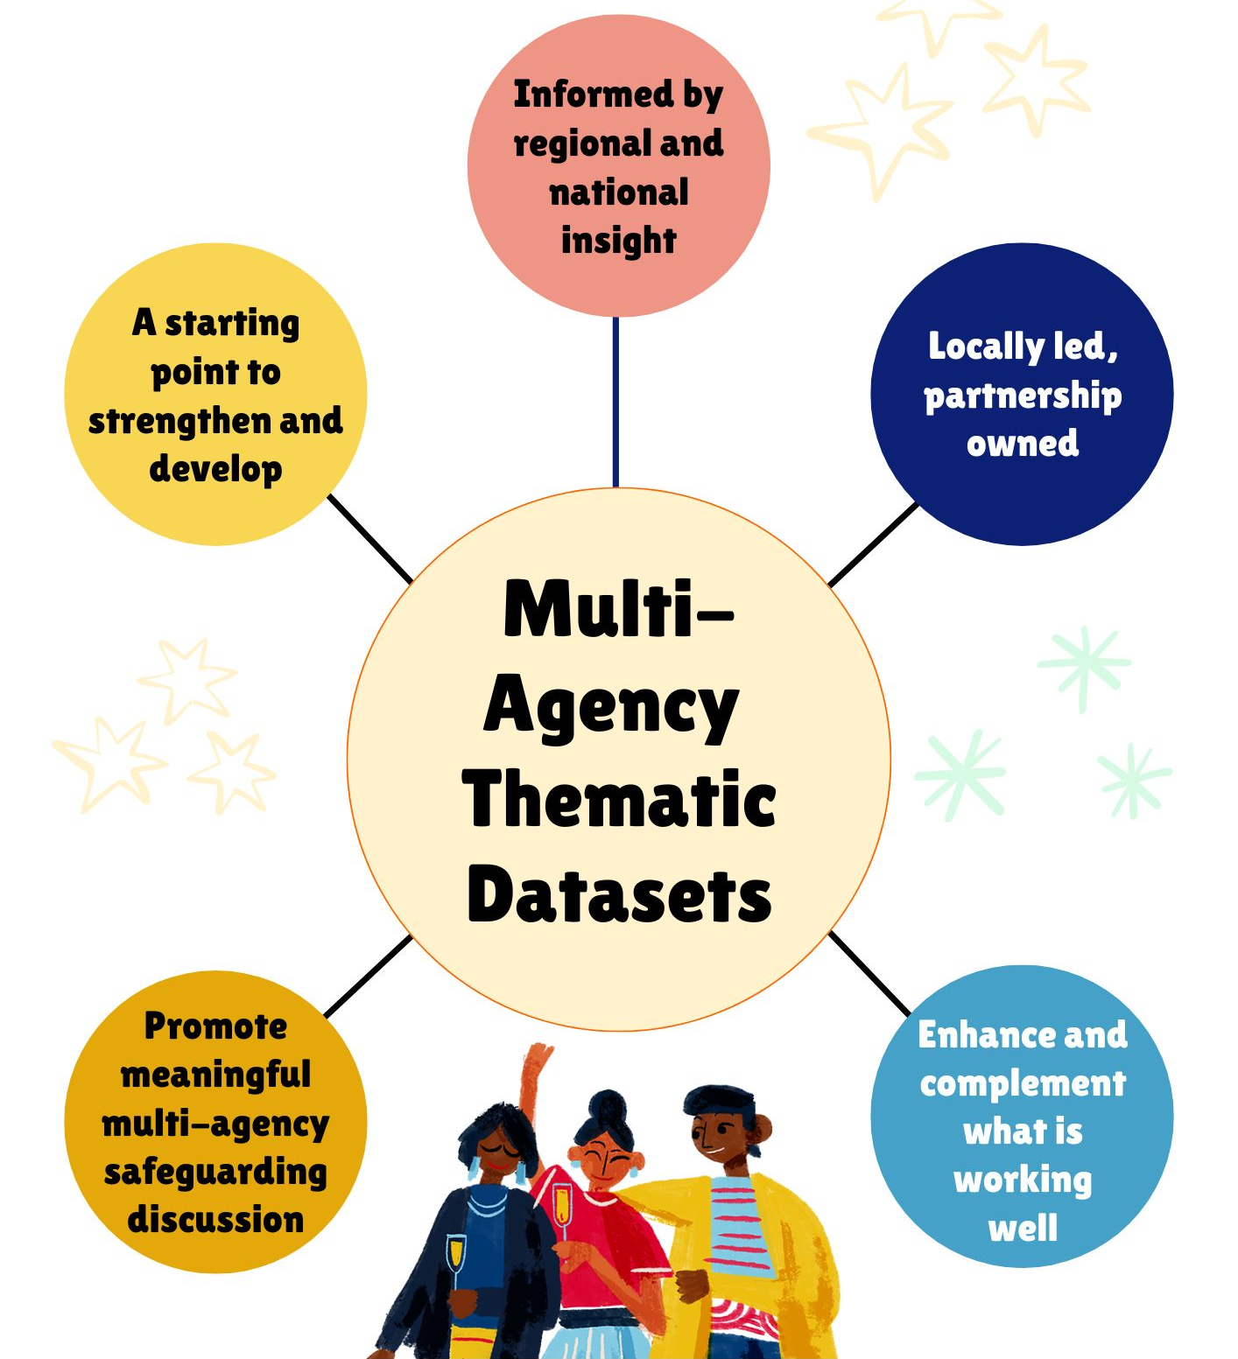

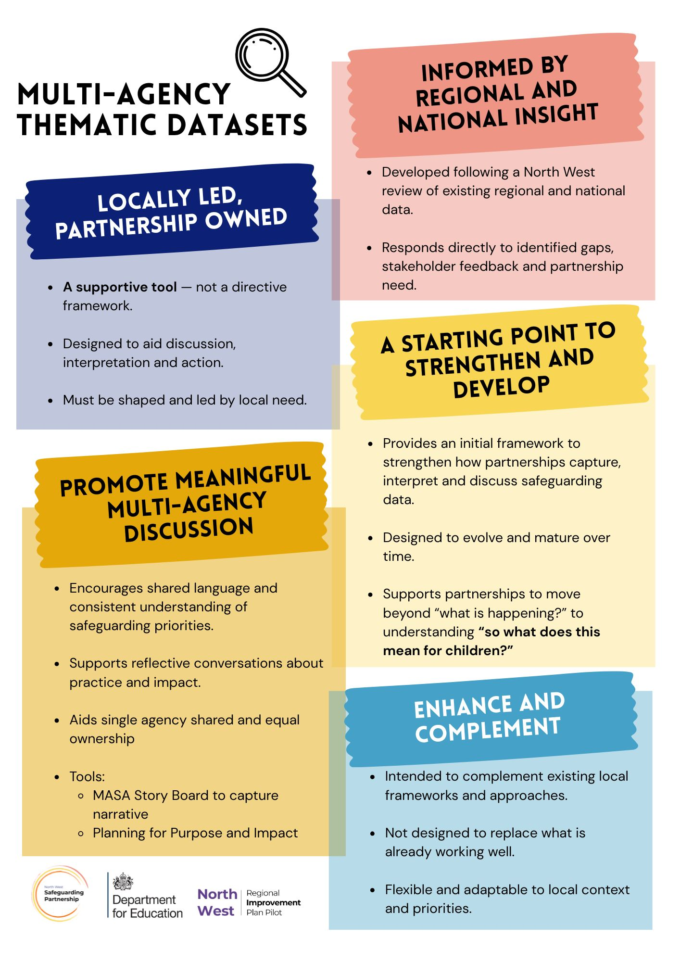

Contents

Commitment 1: Children’s needs are identified early and effectively responded to 5
Commitment 2: Children are protected from risk of harm 7
Commitment 3: Children are effectively safeguarded, and their welfare promoted 11
Commitment 4: Multi-agency partners work together and hold each other to account 13
Fairness and Belonging Data Principles……………………………………………………………...16

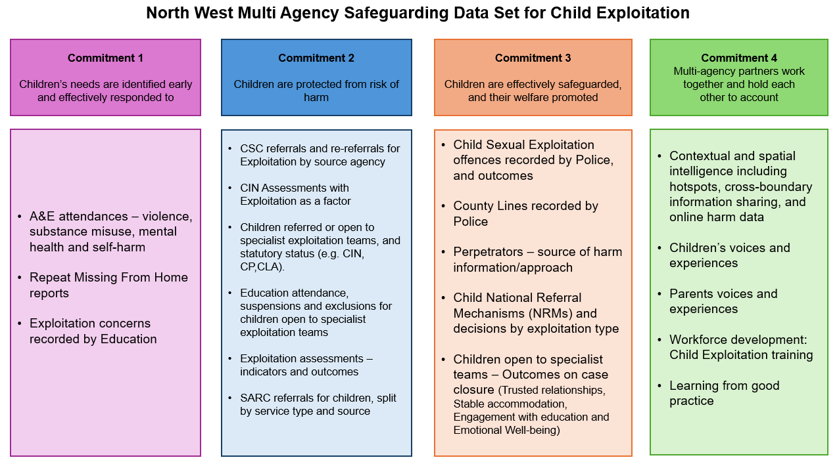

Commitment 1: Children’s needs are identified early and effectively responded to

Measure Name | A&E Attendances 0-17 for non-accidental injuries
Definition | Accident and Emergency attendances in the period, for children aged 0-17 for violence related injuries (including domestic violence), substance misuse, mental health issues, and self-harm.
Why is this important? | A&E attendance is an opportunity to identify and support vulnerable young people at the point of crisis, often following an injury related to violence or exploitation, to build relationships, provide tailored support and pursue positive outcomes.  It is also highlighted as a critical moment in the 2020 CSPR report ‘It was hard to escape’
What could be considered as part of the multi-agency narrative | - Trends by age group, gender and ethnicity to understand trends, needs and disproportionality.  - Trends in attendance reasons e.g. substance use/notable injuries.  - Where available include ED Navigators information on outcomes and impact of interventions.  - Merseyside and GM authorities can access sub-regional comparator data for Assault attendances: Merseyside Trauma Injury Intelligence Group and Greater Manchester VRU Dashboard.  - Rate of A&E attendances among children open to exploitation services vs general 0-17 population.

Measure Name | Repeat missing from home incidents
Definition | Repeat missing from home incidents for children aged 17 and under, recorded by police in the period.
Why is this important? | Being missing from exposes children to an increased risk of harm, exploitation and criminal activity. Being repeatedly reported missing is an indicator of serious harm.
What could be considered as part of the multi-agency narrative | - Number in period of repeat missing episodes by age, gender, sex, ethnicity, disability to identify trends, disparities, disproportionality.  - Analysis of disparities in response timescales and risk assessment of children by ethnicity – see 2023 national research report.  - Return Home Interview completion rates/timeliness/analysis of themes, including inappropriate reporting and demographics.  - Triangulation with attendance data, contextual/hotspot locations, and info from local VCFSE delivery partners including community and young people insights e.g. resident panels/community safety panels and young people police forums.  - Analysis of MFH reports for CLA children, including those placed out of area to identify whether particular groups of children experience disproportionate needs, reduced access to support, or poorer outcomes that may reflect structural/systemic inequalities.
Measure Name | Exploitation concerns recorded by Education
Definition | Child Protection Online Management System (CPOMS) or equivalent, records in the period, regarding Exploitation concerns.
Why is this important? | Educational settings are often the earliest universal service to notice behavioural change and capture early concerns/indicators, and engagement with education is a significant protective factor.  Schools and colleges (including alternative provision and Pupil Referral Units) are a central in young people’s lives, shaping their relationships and social networks, while also being key environments for recognising risk and vulnerability. Embedding a culture of professional curiosity is essential to understanding exposure to harm, including exploitation and discrimination.
What could be considered as part of the multi-agency narrative | - Reports from primary school Key Stage 2-Year 6, secondary schools, colleges, alternative provision and Pupil Referral Units.  - Further analysis against attendance and absence data and correlation with suspensions/exclusions to understand additional vulnerabilities, areas for support and associated factors, including institutional drivers/harm and related contexts e.g. Racism and harmful discipline practices  - Focus on schools/colleges reporting low or high numbers to understand workforce development needs, what is working well across different establishments and opportunities for relationship building and information sharing to increase awareness and identification of exploitation concerns.  - Triangulation with contacts and referrals to social care by education to understand referral rates and advice/support for schools.  - Analysis against specific cohorts v school population e.g. SEND - research highlights increased risk for children with SEND and the role of education in mitigating risk by meeting children’s needs.

Commitment 2: Children are protected from risk of harm

Measure Name | CSC Referrals and Re-referrals for Exploitation, split by source
Definition | Number of referrals and re-referrals to Children’s Social Care re exploitation concerns, with breakdown by source (as per CIN Census).
Why is this important? | Tracking demand for Children’s Social Care, this measure considers the extent to which agencies are making safeguarding referrals for exploitation.
What could be considered as part of the multi-agency narrative | - System-level data can help understand escalation and track children moving between early help, child in need, and child protection plans.  - Consider analysis by age, gender, sex, ethnicity and disability breakdown identify trends, disparities and disproportionality across:  - How many are repeat referrals?  - How many referrals by each agency?  - What are the outcomes of referrals regarding exploitation?  - How consistently are exploitation concerns recorded in referral data?  - How well are structural / systemic factors and contextual factors recorded?  - Where recording and reporting allows consider exploration of secondary reporting factors or additional factors identified at assessment e.g. neglect, domestic violence, SEND and mental health for both children and parents. Consider dip-sampling where data is not available, to understand chronologies.

Measure Name | CIN Assessments with Exploitation as a factor
Definition | Number of CIN assessments with Exploitation as a factor on assessment, in the reporting period (CSE 11A and CCE 24A).
Why is this important? | Monitoring where exploitation is recorded as a factor on assessment to understand levels of recognition and identification. This is key from an equity and fairness perspective, and groups most likely to be rendered ‘invisible’. Recent research highlights misalignment between practice and the way statutory data systems record and report CSAE as factor in under-reporting.
What could be considered as part of the multi-agency narrative | - Proportion of the total number of assessments with factors that identify exploitation – split by type.  - Exploitation type and trend analysis – increases would indicate improved levels of recognition and identification.  - Analysis with demographic data to understand trends/increases for different groups/ages.  - Analysis of other assessment factors prevalent in cases of exploitation to understand related vulnerabilities and needs for children, peers and families. e.g. other exploitation types, sexual abuse, neglect, domestic abuse, mental health, substance use or SENDs for both children and parents.  - Outcome of assessments (CIN plan, CP plan, step-down etc), and analysis against demographics to support identification of equity or disparities e.g. outcomes for affluent families vs those experiencing financial disadvantage.  - Dip-sampling of assessments for children open to specialist teams to quality check factors on assessment/recording of exploitation.

Measure Name | Referrals to specialist exploitation teams
Definition | Number of children referred to specialist exploitation teams at the end of the period, split by statutory status (e.g. CIN, CP, CLA).  Specialist teams may not sit within statutory services due to different delivery models, so consider the services that support children in your area, some may be VCSFE and/or other commissioned services.
Why is this important? | Monitoring demand for specialist exploitation teams/specialist interventions and support for exploitation.
What could be considered as part of the multi-agency narrative | - Demographics including age, gender, disabilities and ethnicity to understand trends, needs and disproportionality.  - Analysis of children not meeting referral thresholds for support, to understand demand, equity and fairness, and alternative/lower level support for children identified with exploitation concerns.  - Are services commissioned or internal? Is the partnership assured that support covers aspects relevant to child exploitation e.g. parent, carer, family and peer group support. Is demand, uptake and impact of this support well understood by the partnership?

Measure Name | Children open to specialist exploitation teams
Definition | Number of children open to specialist exploitation teams at the end of the period, split by statutory status (e.g. CIN, CP, CLA).  Specialist teams may not sit within statutory services due to different delivery models, so consider the services that support children in your area, some may be VCSFE and/or other commissioned services.
Why is this important? | Monitoring the number of children that require specialist intervention and support for exploitation concerns.
What could be considered as part of the multi-agency narrative | - Demographics including age, gender, disabilities and ethnicity to understand trends, needs and disproportionality.  - Split by exploitation type, statutory status and living arrangements to understand support needs  - Length of time open to exploitation team  - How many are open regarding non-recent exploitation  - Is the ‘source of harm’ well understood? e.g. lone offender or group based, online or contact offences etc
Measure Name | Children open to specialist teams - Attendance, suspensions and exclusions
Definition | Education attendance, suspensions and exclusions for children open to specialist exploitation teams.  Specialist teams may not sit within statutory services due to different delivery models, so consider the services that support children in your area, some may be VCSFE and/or other commissioned services
Why is this important? | Attending school full time can be a protective factor, and preventing exclusion reduces the risks around child exploitation. Research shows there is a relationship between school exclusion and child exploitation. Causality is less clear, but the relationship between the two is important. Permanent school exclusion can act as an escalation of risk on a pathway where risk is already likely to have been evident. Being excluded from school was highlighted as a critical moment in the 2020 CSPR report ‘It was hard to escape’
What could be considered as part of the multi-agency narrative | - Demographics including age, gender, disabilities and ethnicity to understand trends, needs and disproportionality.  - Split by exploitation type, statutory status and living arrangements to understand support needs  - Trends over time and by establishment. Consider potential policy and system changes/actions in response to suspension levels, and subsequent impact of those changes.

Measure Name | Exploitation assessments – indicators and vulnerability factors
Definition | Number of specialist exploitation assessments or screening tools completed in the period
Why is this important? | Child exploitation assessment tools are used to understand risk indicators, vulnerability factors, safety and stability for children.  Research has highlighted variability in the use of exploitation screening and scored assessment tools so it is vital that partnerships are assured tools are appropriate and remain fit for purpose and useful.
What could be considered as part of the multi-agency narrative | - Analysis of indicators and vulnerability factors against demographics to understand indicators and risk factors against age, gender, ethnicity, and SEND to understand needs, themes, disproportionality.  - Numbers where exploitation concerns for a child are categorised as vulnerable to, suspected, or known/subject to.  - Use of ‘professional judgement’ scores to ensure assessments capture all concerns – are there patterns that highlight assessments are not capturing all relevant needs and indicators for children that are being exploited e.g. safety and stability concerns and other factors that may not fit easily into ‘risk indicator’ categories  - Important information regarding perpetration type/approach, or context e.g. a specific location, school or community setting, can be difficult to capture in some CE assessment tools – consider how this information is captured and reported to inform safety planning and disruption activity  - How is the use of screening and assessment tools quality assured – also consider use of the research findings highlighted above to understand:  - Does the assessment tool conflate risk and harm? This can have potentially serious consequences for safeguarding  - The risk of screening out young people e.g. by single agency completion, lack of guidance etc  - Is the tool appropriate for some groups e.g. disabled children  - Is the tool strengths or deficit based?  - Are strengths and protective factors included?  - Is the child, peers or family included in assessing?

Measure Name | SARC referrals for children, split by service type and referral source
Definition | Number of referrals Sexual Abuse Referral Centre for children in the period, split by service type and referral source.
Why is this important? | Monitor uptake of specialist services for rape, sexual assault and abuse. Monitoring referral source can assist with awareness raising activity across partnership and public. NHS data indicates self-referrals remain low, suggesting many survivors may not be aware they can access services without going to the police
What could be considered as part of the multi-agency narrative | - Understand referrals by different agencies and self-referral numbers.  - Support type; e.g. forensic exam, counsellor, ISVA  - Analysis and narrative from SARC performance reports re referral trends, local pathway issues, service innovations, service user feedback.  - Split by age, gender and ethnicity where available to understand under-reporting and disproportionality. (NHSE report that underrepresented cohorts include LGBTQ+, ethnic minority groups and boys).

Commitment 3: Children are effectively safeguarded, and their welfare promoted

Measure Name | Child Sexual Exploitation offences recorded by Police
Definition | Number of CSE offences recorded in the period, and investigation outcome types for those with offenders identified
Why is this important? | CSE is a type of CSA, which is under reported and under identified, with official data showing a decreasing trend in CSE recorded crimes. A good understanding of offences reported to the police is required to identify, respond to, and prevent children being harmed.
What could be considered as part of the multi-agency narrative | - Analysis of CSE offences by victim demographics, age, gender, sex, ethnicity, including statutory status and education information to understand disproportionality and ensure children’s needs and vulnerabilities are prioritised.  - Analysis of offence type, MO and ‘Source of Harm’ e.g. cyber enabled and online offending, peer/child-child offences, lone offenders, group based or networked offending.  - Are links to CCE considered and understood?  - Analysis and understanding of emerging threats e.g. new approaches/exploitation techniques like sextortion and deep fakes.  - Investigation outcomes - consider what are the rates of positive outcomes for the different offence types? Is there disparity?  - Consider the length of investigations to understand the impact on children and families.

Measure Name | County Lines recorded by Police
Definition | Number of current/active county lines recorded by the Police at the end of the period.
Why is this important? | County Lines is where illegal drugs are transported from one area to another, often across police and local authority boundaries (although not exclusively), usually by children or vulnerable people who are coerced into it by gangs. The ‘County Line’ is the mobile phone line used to take the orders of drugs. Importing areas (areas where the drugs are taken to) are reporting increased levels of violence and weapons-related crimes.
What could be considered as part of the multi-agency narrative | - Breakdown of how many lines are internal-external to the locality  - Overview and analysis to inform effective partnership practice – e.g. ‘external’ linked areas across the UK, emerging trends of note e.g. grooming MO/approach/tactics, and new drug types  - Consider dip sampling to ensure that appropriate referrals and responses for children identified in county lines investigations by demographic data.

Measure Name | Child National Referral Mechanisms (NRM) referrals and decisions by exploitation type
Definition | Number of child NRM’s recorded by Police in the period
Why is this important? | The National Referral Mechanism (NRM) is a framework for identifying and referring potential victims of modern slavery and ensuring they receive the appropriate support. Child victims do not have to consent to be referred into the NRM and must first be safeguarded and then referred into the NRM process.
What could be considered as part of the multi-agency narrative | - Split by exploitation type  - Where available, how many referrals were made to Independent Child Trafficking Guardianship Service (ITCGS), including referring agencies.  - How many NRMs result in positive conclusive grounds (CG) and reasonable ground (RG) decisions?  - Analysis of age, gender and ethnicity to understand needs and disproportionality/rates of positive decisions for British and non-British children.  - Chronology analysis to identify timeliness of referrals – e.g. arrests / intelligence relating to exploitation to see if children are bring referred when they should be, including disparities as above  - Understanding of the impact of outcomes/decisions e.g. on criminal justice outcomes, civil/criminal order use, disruption/interventions etc

Measure | Children open to specialist teams – Outcomes on case closure
Description | Outcomes reported on case closure to specialist services. Including trusted relationships, stable accommodation, engagement with education and emotional well-being.
Why is this important? | Understanding outcomes for children and families that are supported by specialist services is vital to understand the effectiveness and impact of services in increasing safety and stability for children that are at risk of, or subject to exploitation.
What could be considered as part of the multi-agency narrative | - Key outcomes to focus on include:  - Trusted relationships have been established  - Accommodation is deemed to be suitable and stable,  - Engagement with education has improved  - Children’s emotional wellbeing has improved,  - Children’s goals (where set), have been achieved  - Information can be gleaned from assessments, audits or bespoke recording of professional judgement over the time a young person has been open to a specialist team.  - Analysis against demographics to understand needs and areas to focus improvement work (e.g. identified disproportionality and disparities in improved/positive outcomes).

Commitment 4: Multi-agency partners work together and hold each other to account

Measure | Contextual and spatial intelligence including hotspots, cross-boundary information sharing, and online harm data
Description | Sharing narrative and insights regarding known and suspected exploitation risks across the places and spaces children frequent, including on and off-line.
Why is this important? | National Tackling Child Exploitation (TCE) Principles and their recent update, highlight that understanding the context of harm within spaces and places children spend time is important for collectively partnership action to mediate and address potential harm.  This applies across all spheres of children and young people’s lives – including families, schools, peer groups, communities and online interactions – and as such, all these spaces and places become arenas for intervention.
What could be considered as part of the multi-agency narrative | - Consider the breadth of multi-agency partners that can provide insights and understanding about places and spaces, including;  - Community Safety  - Neighbourhood Policing  - VCSFE organisations e.g. Youth Zones, Youth Federations and Associations and wider youth services  - School and Further Education leaders and Designated Safeguarding Leads  - Housing provider safeguarding leads  - Non-traditional safeguarding partners highlighted in Contextual Safeguarding research, i.e. those who have ‘eyes and ears’ on the places and spaces where children and young people spend their time, such as shop owners, taxi drivers, youth services, etc.  - Consider using Story Board resources and Partnership Intelligence Forms or Portals to gather insight and narrative.  - Consider use of surveys to understand children and young peoples perceptions of safety in different contexts.

Measure | Children’s voices and experiences
Description | Gathering feedback and experiences from children and young people regarding the care and support received
Why is this important? | Understanding lived experiences to improve practice and services for children and families
What could be considered as part of the multi-agency narrative | Do:  - Children express feeling heard and understood during safeguarding processes?  - Children report improved emotional wellbeing and safety?  - Children describe positive relationships with trusted adults and professionals?  - Consider how and what feedback is gathered across partnership agencies that may be captured in different ways e.g. police / health  - Qualitative data/feedback from young people, families and communities is cross-cutting and should be utilised to understand any number of the measures included within this dataset in order to inform discussion, analysis and decision-making.

Measure Name | Parents voices and experiences
Definition | Feedback from parent and carers regarding support received regarding the care and support received
Why is this important? | Understanding lived experiences to improve practice and services for children and families
What could be considered as part of the multi-agency narrative | Do:  - Parents report feeling listened to, respected and supported by professionals?  - Families find services as accessible, inclusive, and culturally sensitive?  - Parents acknowledge improved understanding of exploitation?  - Parents report feeling appropriately safeguarded and supported e.g. risks from perpetrators - indicators could be family level plans, wider agency intervention e.g. housing  - Are parents contexts, needs and vulnerabilities understood - as per the I wanted all them to notice report.  - Consider availability/offer alongside referrals and uptake of;  - Parental support to deal with their trauma  - Family support e.g. holistic family therapy referrals – including referrals made and length of support  - Peer support - available networks and parental support groups – including how well they are they valued by parents.  - Parents as partners – consideration of parental engagement and involvement across all data measures in dataset e.g. whether they have played a role in plans, interventions etc - see National Tackling Child Exploitation (TCE) Principles guidance.

Measure Name | Workforce development: Exploitation training
Definition | Number of Exploitation specific training sessions held, multi-agency participants invited including uptake and attendance.
Why is this important? | Workforce development is important to increase staff confidence in identifying and addressing exploitation, and recognising the influence that unconscious bias can have on professionals behaviour and decision making.  Monitoring this data will enable to partnership to understand the extent of awareness raising activity taking place across the multi-agency workforce, and gaps in staff awareness, for targeting of future training.
What could be considered as part of the multi-agency narrative | - Consider the workforce that receive training e.g. all front-line and community staff. This should be in addition to wider practice development work e.g. supervision, action learning, practice frameworks.  - Breakdown of the training uptake and attendance by single agency/departments to ensure all partners are well engaged.  - Surveys to capture the impact of training on knowledge base and changes in practice.  - Evaluation and impact plans to include follow up focus groups/surveys with participants to understand long term impact on knowledge and practice  - Feedback from young people and families, supervision and practice audits on impact and effectiveness of workforce development.

Measure Name | Learning from good practice
Definition | Sharing good practice examples in cases of exploitation across the partnership.
Why is this important? | Sharing best practice examples across the partnership will influence further good practice, and create a learning culture to enable continuous improvement based upon what works in improving outcomes for children.
What could be considered as part of the multi-agency narrative | Why was it good, how is that captured, shared, and used to influence continuous improvements. Consider different mechanisms to capture;  - Good practice highlighted in multi-agency practice reviews where exploitation was a factor.  - Multi-agency audits (including Section11 audit)  - Feedback  - Reflective sessions  - Knowledge management systems e.g. SharePoint/Teams channels  - Internal communication tools e.g. newsletters and emails  - Website/Intranet updates  - Training management systems e.g. to share learning materials and capture uptake, attendance and feedback.

