North West Multi-Agency Neglect Dataset

Neglect is currently a strategic priority area for 17 of the 24 multi-agency safeguarding partnerships in the North West. This dataset and guidance has been collaboratively developed in response to stakeholder feedback and identified needs. It is designed to support and enable North West MASA’s to embed and enhance the capture and discussion of multi-agency data and insights related to child neglect. Safeguarding partnerships are invited to utilise and adopt this dataset as they feel appropriate, to complement existing frameworks, rather than replace what is already working well.

This document details proposed data measures, potential sources, and guidance on why these measures have been deemed important and considerations for sub-group focused discussions. The guidance can be used to promote reflection in relation to neglect practice, enable shared and consistent language and understanding and report baselines for comparison and benchmarking.
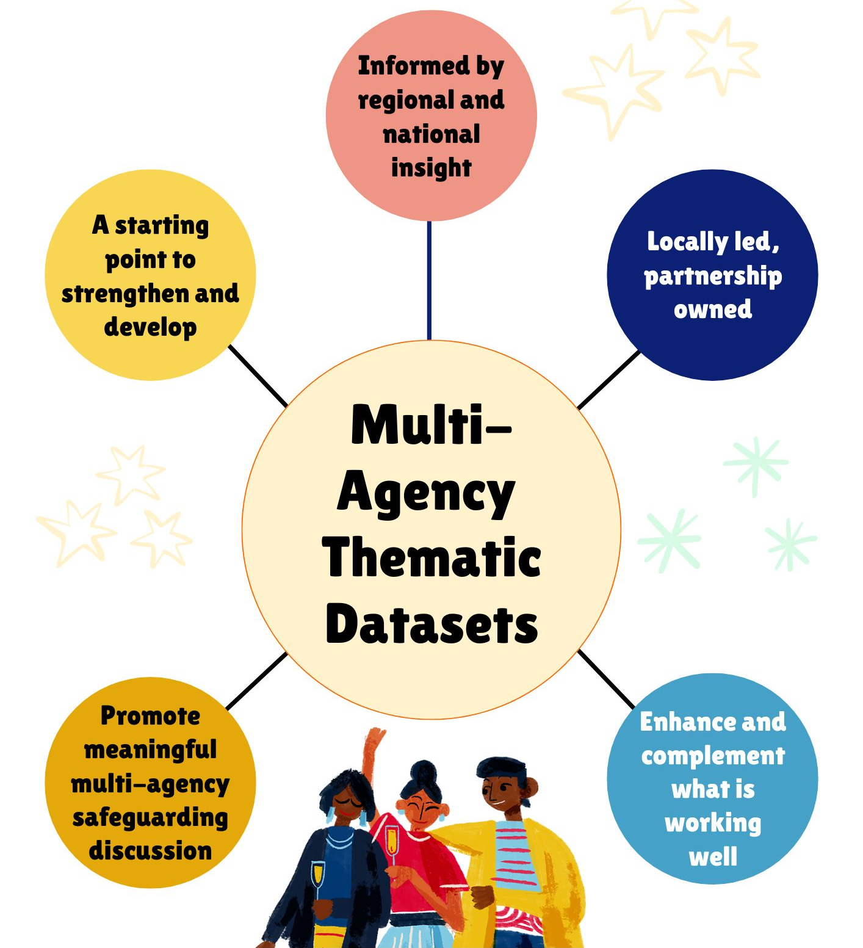

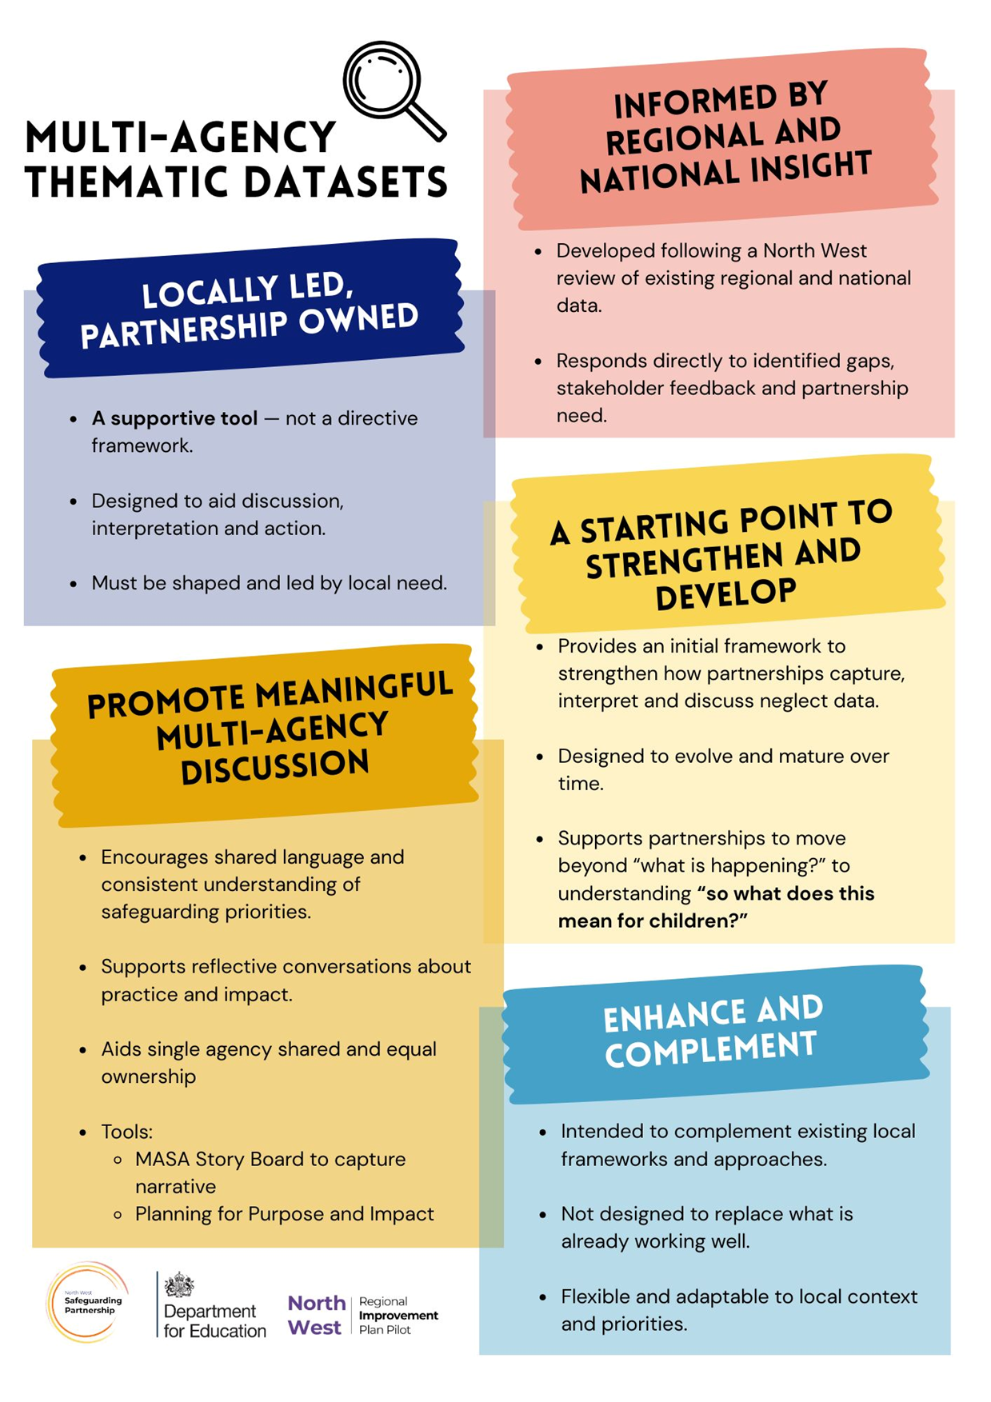

The NSPCC define child neglect as “the ongoing failure to meet a child's basic needs and the most common form of child abuse. A child might be left hungry or dirty, or without proper clothing, shelter, supervision or health care. This can put children and young people in danger. And it can also have long term effects on their physical and mental wellbeing.” Adding, Neglect can be a lot of different things, which can make it hard to spot. Where possible, the measures have been categorised within the 4 domains of neglect the NSPCC refer to;
- Physical neglect A child's basic needs, such as food, clothing or shelter, are not met or they aren't properly supervised or kept safe.
- Educational neglect A parent/carer doesn't ensure their child is given an education.
- Emotional neglect A child doesn't get the nurture and stimulation they need. This could be through ignoring, humiliating, intimidating or isolating them.
- Medical neglect A child isn't given proper health care. This includes dental care and refusing or ignoring medical recommendations.
This dataset is aligned to the DfE Families First Partnership Guidance, embedding the principles of family help, partnership working and family led decision-making.
Additional measures are included that were proposed in sub-regional data development sessions as potential indicators of families needing help and support. These measures are included for that purpose, they are not indicators of neglect, and relate to public health, poverty, inequality and escalating needs for children and families.

Contents

Commitment 1: Children’s needs are identified early and effectively responded to 6
Commitment 2: Children are protected from risk of harm 8
Commitment 3: Children are effectively safeguarded, and their welfare promoted 9
Commitment 4: Multi-agency partners work together and hold each other to account 11
Additional measures: Families needing help and support 12
Fairness and Belonging Data Principles……………………………………………………………...14

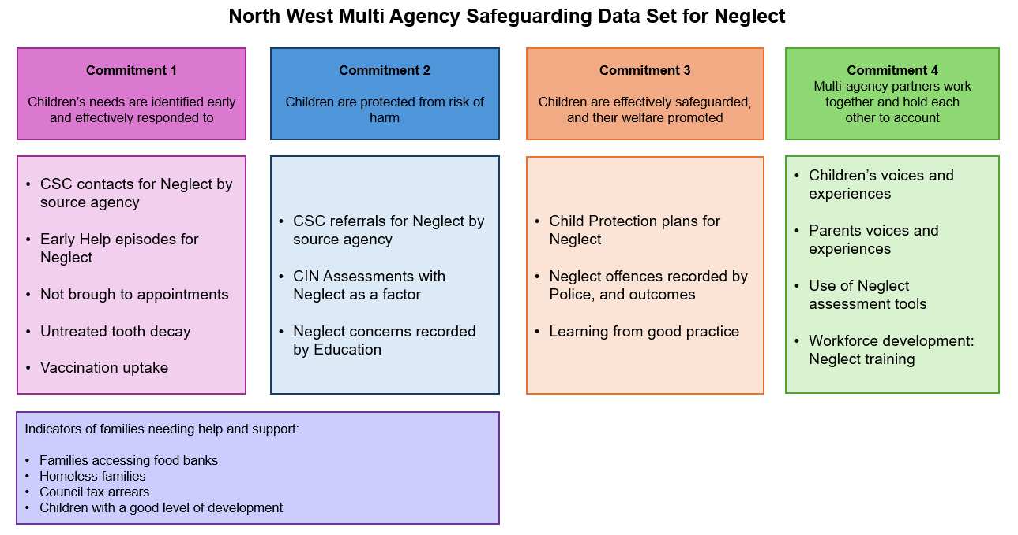

Commitment 1: Children’s needs are identified early and effectively responded to

Measure Name | Contact for Neglect with source agency
Definition | Number of contacts for neglect, for individual children received by the point of access for Children's Social Care services in the reporting period.  This should include all contacts for Neglect, including those that are repeats for the same child, or requests for information on an existing child.  Include supplementary information to providing count by source agency (categories aligning with the CIN Census referral sources)
Why is this important? | Contacts are a primary indicator of multi-agency working. The social care front door acts as a coordination point for agencies to make contact regarding children who may need help or protection in relation to neglect concerns.
What could be considered as part of the multi-agency narrative accompanying the data | - System-level data can help understand escalation and track children moving between early help, child in need, and child protection plans for neglect.  - Identifying repeat cases and episodic patterns is essential to distinguish between one-off incidents and ongoing neglect.  - How many contacts by each agency?  - What are the outcomes of contacts regarding neglect?  - How consistently are neglect concerns recorded in contact data?  - Where recording and reporting allows consider exploration of secondary reporting factors or additional factors identified at assessment e.g. sexual abuse, exploitation, domestic violence and SEND for both children and parents. Consider dip-sampling where data is not available, to understand chronologies.

Measure Name |  | Children open to Early Help for Neglect
Definition |  | Number of children receiving Early Help services for neglect, at the end of the reporting period.
Why is this important? |  | Early Help data forms a critical component in supporting children and families where neglect is a concern.
What could be considered as part of the multi-agency narrative accompanying the data |  | - How many Early Help assessments for neglect have been undertaken?  - Which agencies are invited to, and have attended and contributed to Team Around the Family/Child Meetings?  - How many children have been closed due to escalation from Early Help to Children's Social Care?
Measure Name | Not brought to appointments
Definition | Number of children (0-17) recorded as not attending appointments in the reporting period – from monthly monitoring for Secondary Uses Service for paediatric departments.
Why is this important? | Was not brought (WNB) applies to children and young people (who require the presence or support of a parent or carer to attend appointments), that did not attend a planned appointment and had not cancelled the appointment.  WNB has replaced the use of ‘did not attend’ (DNA) to reflect that children and young people rely on parents/carers to attend appointments. It allows professionals to consider the impact of the WNB on the child, and plan what support they may need. Repeated WNBs can be an indicator of neglect, abuse, or significant unmet need.

Measure Name | Untreated Tooth Decay
Definition | Percentage of 5 year olds with experience of visually obvious dental decay (Fingertips Child & Maternal Health Profile)
Why is this important? | Oral health is an integral part of overall health; when children are not healthy this affects their ability to learn, thrive and develop. This indicator therefore links to a key policy: Getting the Best Start in Life. Poor oral health is a priority under Best Start in Life, it was also a topic of a Health Select Committee inquiry, and the most common cause of hospital admission for 5 to 9 year olds. This indicator allows benchmarking of oral health of young children across England, and is an excellent proxy measure of assessing the impact of the commissioning of oral health improvement programmes on the local community. Dental caries is a synonymous term for tooth decay.

Measure Name | Vaccination uptake
Definition | 3 measures, all available annually (new for 2024-25) via Fingertips Public Health Profiles;  - Babies who received at least 3 doses of a DTaP vaccine before the age of 8 months  - Children who received at least 1 dose of MMR vaccine bet. 1-1.5yrs  - Children, aged 5, who received a reinforcing dose of DTaP/IPV and at least 2 doses of an MMR vaccine between the ages of 15 yrs
Why is this important? | Vaccination uptake is useful to consider in children’s safeguarding as potential indicator of cumulative harm. Vaccinations are not mandatory in the UK , and cannot be given without consent. Refusing to vaccinate a child might be classified as medical neglect if it poses a significant risk to a child’s health and well-being. Data is available annually at the Counties-Unitary Authority level, and at individual GP level.

Commitment 2: Children are protected from risk of harm

Measure Name | Referrals for Neglect with source agency
Definition | Number of referrals for neglect to Children’s Social Care, with breakdown by source (as per CIN Census definitions).
Why is this important? | Tracking demand for Children’s Social Care, this measure considers the extent to which agencies are making safeguarding referrals for neglect.
What could be considered as part of the multi-agency narrative accompanying the data | - System-level data can help understand escalation and track children moving between early help, child in need, and child protection plans.  - How many are repeat referrals?  - How many referrals by each agency?  - What are the outcomes of referrals regarding neglect?  - How consistently are neglect concerns recorded in referral data?  - Where recording and reporting allows consider exploration of secondary reporting factors or additional factors identified at assessment e.g. e.g. sexual abuse, exploitation, domestic violence and SEND for both children and parents. Consider dip-sampling where data is not available, to understand chronologies.

Measure Name | CIN Assessments with Neglect as a factor
Definition | Number of CIN assessments with Neglect as a factor on assessment, in the reporting period.
Why is this important? | Abuse or Neglect is the most prevalent primary need recorded in CIN assessments, accounting for over half of all children assessed nationally in 2024.  It is important to monitor where neglect is recorded as a factor on assessment to understand the monitor neglect specifically.
What could be considered as part of the MA narrative | Analysis of other assessment factors prevalent in cases of neglect to understand related vulnerabilities and needs for children and families. e.g. sexual abuse, domestic abuse, mental health or exploitation.

Measure Name | Neglect concerns recorded by Education
Definition | Child Protection Online Management System (CPOMS) for Neglect, including attendance and absence
Why is this important? | CPOMS records for Neglect will include school observations such as children arriving without food or showing signs of neglect.  Attendance and absence data may highlight additional vulnerabilities and areas for support e.g. emotionally based school avoidance, neurodivergence and challenges in waiting lists for assessment.

Commitment 3: Children are effectively safeguarded, and their welfare promoted

Measure Name | Child Protection plans for Neglect
Definition | Number of children with a Child Protection Plan categorised as Neglect, starting in the reporting period.  In the unlikely event that a single child has multiple Child Protection Plans starting in the same period, count each individually i.e. multiple rows per child.
Why is this important? | Track changes in demand for child protection services regarding neglect, and compare conversion rates from lower level activity/understanding of escalation.  Child Protection work is another key point at which agencies will work together to safeguard children. The upcoming reforms indicate that Child Protection Teams should be multi-agency and tracking the impact of these changes will be critical in the coming months.
What could be considered as part of the multi-agency narrative accompanying the data | - An increase in children on CP plans for neglect could indicate risks being managed more appropriately.  - How many children and families received early help?  - Which agencies are invited to, attend and contribute at Core Group Meetings?  - Are families being invited to and supported to attend meetings? Is there evidence that families are sharing thoughts, feelings and inputting into meetings?  - How many children subject to a CP plan for neglect have had a family group decision making meeting?  - How many children and parents were offered an advocate?  - Duration of plans - How many children have been on a CP plan for neglect for over 12 months?  - How many of the CP plans are repeat plans (within 2 years)?  - How many CP plans for neglect have ceased at the first Review of Child Protection Conference (RCPC)?  - Which agencies attend and/or input at Child Protection Review Conference?

Measure Name | Neglect offences and outcomes
Definition | Number of Neglect offences (11A) recorded by Police in the period.
Why is this important? | Neglect is the most prevalent form of recorded abuse, with almost half of all children being on child protection plans for neglect nationally.  It is important to monitor criminal offences of neglect recorded by the police to understand how and when criminal legislation is being used to protect children subject to neglect.
What could be considered as part of the multi-agency narrative accompanying the data | - Analysis/understanding of the different types of neglect offences recorded? e.g. medical, nutritional, emotional, educational, physical and lack of supervision and guidance  - Analysis of trends in neglect offences – a recorded crime can indicate a family situation has reached a point of criticality, high numbers may may indicate a lack of early intervention/help.  - Consider triangulating with data on referrals, strategy meetings and CP plans for Neglect to understand prevalence in social care records v criminal justice action, context, and chronologies for children and families.  - Investigation outcomes - consider what are the rates of positive outcomes for the different types of neglect offence, and what they mean in relation to decision-making and public interest.  Consider the length of investigations to understand the impact on children and families.

Measure Name | Learning from good practice
Definition | Sharing good practice examples in cases of neglect across the partnership.
Why is this important? | Sharing best practice examples across the partnership will influence further good practice, and create a learning culture to enable continuous improvement based upon what works in improving outcomes for children.
What could be considered as part of the multi-agency narrative accompanying the data | Why was it good, how is that captured, shared, and used to influence continuous improvements. Consider different mechanisms to capture;  - Good practice highlighted in multi-agency practice reviews where neglect was a factor  - Multi-agency audits (including Section11 audit)  - Feedback  - Reflective sessions  - Knowledge management systems e.g. SharePoint/Teams channels  - Internal communication tools e.g. newsletters and emails  - Website/Intranet updates  - Training management systems e.g. to share learning materials and capture uptake, attendance and feedback

Commitment 4: Multi-agency partners work together and hold each other to account

Measure Name | Children’s voices and experiences
Definition | Gathering feedback and experiences from children and young people regarding the care and support received
Why is this important? | Understanding lived experiences to improve practice and services for children and families
What could be considered as part of the multi-agency narrative | Do:  - Children express feeling heard and understood during safeguarding processes?  - Children report improved emotional wellbeing and safety at home and school?  - Children describe positive relationships with trusted adults and professionals?

Measure Name | Parents voices and experiences
Definition | Feedback from parent and carers regarding support received regarding the care and support received
Why is this important? | Understanding lived experiences to improve practice and services for children and families
What could be considered as part of the multi-agency narrative | Do:  - Parents report feeling respected and supported by professionals?  - Families describe services as accessible, inclusive, and culturally sensitive?  - Parents acknowledge improved understanding of neglect and how to prevent it?

Measure Name | Use of Neglect assessment tools
Definition | Use of Neglect assessment tools (e.g. GCP2 and Thriving Families), including a breakdown of professionals completing.
Why is this important? | Monitoring the extent to which neglect assessment tools are being used across the partnership supports understanding how well neglect is recognised and responded to, and the difference made in identifying and supporting needs for children and families.
What could be considered as part of the multi-agency narrative | - Which agencies and professionals are completing assessment tools? e.g. social workers, teachers, family support and health visitors.  - How many assessment resulted in further interventions or referrals into social care?  - Consider further analysis to understand early warning signs, needs and strengths identified and change/improvements over time.
Measure Name | Workforce development: Neglect training
Definition | Number of Neglect specific training sessions held, multi-agency participants invited including uptake and attendance
Why is this important? | Workforce development is important to increase staff confidence in identifying and addressing neglect, and recognising the influence that unconscious bias can have on professionals behaviour and decision making regarding lower-level neglect issues.  Monitoring this data will enable to partnership to understand the extent of awareness raising activity taking place across the multi-agency workforce, and gaps in staff awareness, for targeting of future training.
What could be considered as part of the multi-agency narrative | - Consider the workforce that receive training e.g. all front-line and community staff.  - Breakdown of the training uptake and attendance by single agency/departments to ensure all partners are well engaged.  - Surveys to capture the impact of training on knowledge base and changes in practice.  - Follow up focus groups/surveys with participants 3 months following training to understand long term impact on knowledge and practice

Additional measures: Families needing help and support

The following data measures were discussed in sub-regional data development sessions as potential indicators of families needing help and support. These measures are not indicators of neglect, and relate to public health, poverty, inequality and escalating needs for children and families. Locally recent data may be available at smaller geographies, and links to National datasets have been included where available.

Measure Name | Children not meeting good level of development (GLD)
Definition | Number and percentage of children not meeting GLD <5yrs (EYFS Profile definition)
Why is this important? | The government has set a milestone of 75% of 5-year-olds reaching a good level of development by 2028 (Giving every child the best start in life). Data is available annually at the Local Authority and Regional level.

Measure Name | Number of families accessing food banks
Definition | Number of families accessing food banks in the reporting period
Why is this important? | This measure is included as a potential indicator of escalating need for families, linked to poverty.  It is acknowledged that many families that need help may not use food banks, and data can be skewed by food bank accessibility and operations.

Measure Name | Homeless Families
Definition | Housing instability – Number of children in Bed & Breakfast accommodation, in the period.
Why is this important? | This measure is included as a potential indicator of escalating need for families - linked to poverty, housing instability and hidden pressures on families and overall well-being.

Measure Name | Council Tax Arrears
Definition | Number of households with children in council tax arrears, in the reporting period.
Why is this important? | This measure is included as a potential indicator of escalating need for families - linked to poverty, financial instability and hidden pressures on families and overall well-being.

